Skip to content

- Who We Are
- What We Do
- Results
- Portfolio
- Contact Us

Inside the Strategy That Built National SEO Authority for a PI Law Firm
AIO
Results that speak for themselves

Key Stats & Results


385% Organic Traffic Growth

8,300+ Ranking Keywords
Behind the transformation

How a National PI Law Firm Scaled Organic Growth and National Visibility with SEO
A fast-growing personal injury law firm partnered with Rankings.io to transform its organic search strategy and expand beyond a strong regional presence. In under three years, the firm achieved 385% growth in organic traffic, expanded from 4 to 40+ locations, and built national SEO authority, all while creating a scalable foundation for long-term growth across both traditional and AI-driven search.
FROM CHALLANGES TO SUCCESS


The Challenge

When this fast-growing personal injury law firm partnered with Rankings.io, their goal was clear: Expand from a strong regional presence into a scalable national brand.
The firm had already built meaningful brand awareness through social media and other marketing channels, generating strong branded search demand. However, its organic search presence lagged behind, with limited non-branded visibility and an underdeveloped SEO foundation.
At the start of the engagement, the firm’s website reflected early stage SEO maturity, with low authority, minimal content, and limited geographic reach. Despite significant growth opportunities, achieving national expansion required building a scalable organic strategy capable of supporting both rapid location growth and increasing competition across multiple markets.
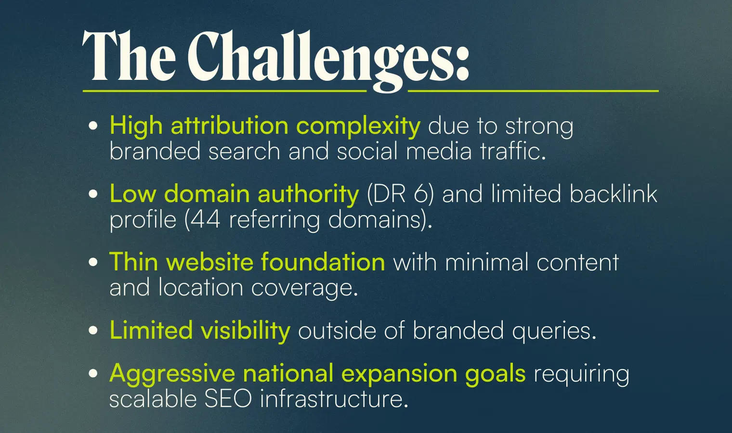


How We Did It: The Strategy

Rankings.io deployed a comprehensive SEO + AI search strategy designed to scale alongside the firm’s rapid expansion. Rather than applying generic tactics, we built a system that could support national growth while reinforcing the firm’s existing brand momentum.

SEO Strategies
Our SEO for lawyers approach focused on three core pillars:

1. Technical SEO Foundation
We strengthened the website’s core infrastructure to support scalability, ensuring search engines could efficiently crawl, index, and prioritize new content as the site expanded.
This included improvements to site architecture, internal linking, and overall performance, creating a foundation capable of supporting thousands of new pages and multi-location growth.

2. Content Strategy & Authority Building
We developed and deployed a high-volume, scalable content strategy targeting both city- and state-level search opportunities.
This approach enabled the firm to expand into new geographic markets while building topical authority across personal injury-related queries. We structured content to align with user intent and support both local rankings and broader non-branded visibility.

3. Link Building & Digital PR
To rapidly increase domain authority, Rankings.io executed an aggressive link-building campaign focused on high-quality backlinks.
We leveraged citations, press releases, and digital PR initiatives to strengthen both SEO performance and overall brand visibility, helping the site compete in increasingly competitive markets nationwide.

4. Local SEO & Geographic Expansion
We supported the firm’s expansion into new markets by:
- Identifying high-value geographic opportunities
Collaborating on the launch and verification of new Google Business Profile locations
Building supporting local content to reinforce geographic relevance
This strategy enabled the firm to scale from just a handful of locations to a nationwide footprint.

AI Search Optimization
As AI-powered search continues to reshape how users discover legal services, Rankings.io positioned the firm for long-term visibility across both traditional and emerging search platforms.

1. AI Search Visibility
We structured content to increase visibility across AI-driven search experiences, including Google AI Overviews and conversational search platforms, ensuring the firm could appear in high-intent, non-branded discovery queries.

2. Conversational Content Optimization
Rankings.io optimized content for natural language queries, aligning with how users ask legal questions in AI-driven environments. This improved the likelihood of AI-generated responses surfacing and citing the firm.

3. Brand Authority Signals
We reinforced trust signals through consistent brand mentions, authoritative backlinks, and structured content, strengthening the firm’s credibility across both traditional search engines and AI models.


Before & After
After implementing a scalable, multi-layered SEO strategy, the firm achieved significant growth across authority, rankings, and organic traffic.
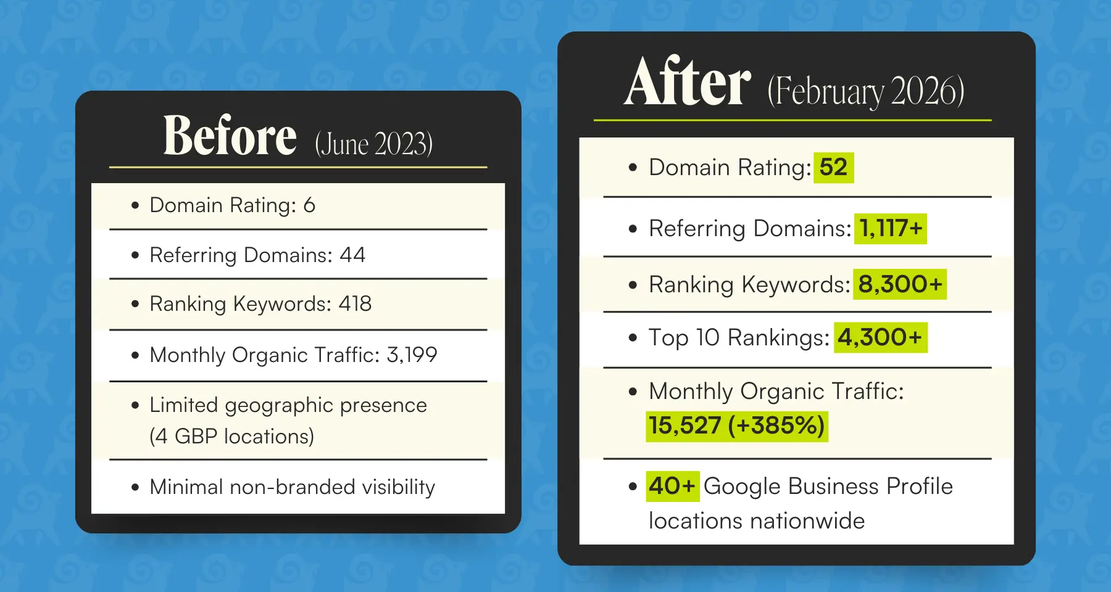

Key Wins
- 385% increase in organic traffic, scaling from 3,199 to 15,527 monthly visits
- Domain Rating growth from 6 → 52 through sustained authority building
- Backlink profile expanded from 44 to 1,117+ referring domains
- Keyword footprint increased from 418 to 8,300+ ranking keywords
- 4,300+ keywords ranking in the top 10 positions
- Expansion from 4 to 40+ Google Business Profile locations
- Strong local engagement, with core locations generating 400–500 calls per month and
- 3,600+ calls in a single month across listings

Ready to Grow Your Firm?
This case study demonstrates what’s possible when a scalable SEO strategy aligns with ambitious national growth goals.
As the legal marketing landscape evolves, firms that combine strong SEO fundamentals with AI search optimization will best position themselves to win both today’s rankings and tomorrow’s discovery channels.
At Rankings.io, we specialize exclusively in digital marketing for lawyers, with deep expertise in personal injury marketing.
Our AI SEO services can position your firm for both traditional search engines and the next generation of AI-powered search experiences.

